**Answers**



Lutterworth & District

Charity No: 247288

7 High Street

Lutterworth LE17 4AT

Telephone 01455 557116

Email: info@ageconcernlutterworth.org.uk

WEBSITE: www.ageconcernlutterworth.org.uk

Spring 2021

**In this special edition, find plenty of puzzle & games inside to keep you busy for a while!**

We hope to resume our normal activities soon and look forward to seeing everyone again!

***Making the most of life***

Events, News & Information

We hope you enjoy the puzzles & games in this booklet! To check your answers, read below.

Don’t be afraid to have a look if you get stuck!

1. Burrow 2. Cow 3. The Northern Lights 4. Yew, Scots Pine and Juniper 5. The Oak (Cork Oak) 6. A Worm 7. A Mute Swan 8. Giraffe 9. Salamanders & Armadillos

ACROSS: 1. Mishandled 7. Rambler 8. Free 10. Arch 11. Everyone 13. Fenced 15. Catgut 17. Slippers 18. Scan 21. Port 22. Swaddle 23. Discontent

DOWN: 1. Mimic 2. Salt 3. Arrive 4. Deferred 5. Erelong 6. Breakfast 9. Sentences 12. Despotic 14. Nairobi 16. Prison 19. Cadet 20. Mare

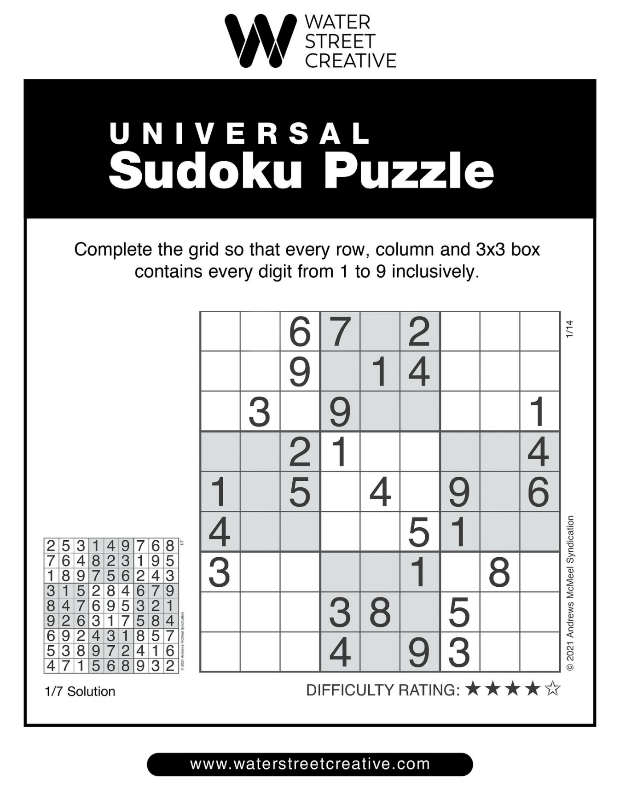

DANGEROUS

His horse’s name is Friday.

1. Telephone 2. Carpet 3. Television 4. Microwave 5. Dustbin 6. Hoover 7. Footstool 8. Toolbox 9. Curtains 10. Cupboard 11. Mantlepiece 12. Kettle 13. Mirror 14. Tablecloth 15. Saucepan

1) a 2) b 3) a 4) a 5) c

1. Ball 2. Mail 3. Pipe 4. Match 5. Bone 6. Glass 7. Band 8. Table 9. Litter 10. Fly

1) c 2) a 3) c 4) c 5) d 6) d 7) a 8) c 9) b 10) d

First, the farmer takes the goat across. The farmer returns alone and then takes the wolf across, but returns with the goat. Then the farmer takes the cabbage across, leaving it with the wolf and returning alone to get the goat.

Crossword

Sudoku

Sports Quiz

Nature Quiz

Word Scramble

Link Words

Riddle

Definitions

Word Wheel

Logic Puzzle





SCAM WATCH

Be careful and watch out for scams! A lot of scammers are deliberately targeting people with scams relating to the coronavirus pandemic.

Scammers have been contacting people pretending to be from the NHS, asking you to sign up for your vaccination. They’ll then say you need to give them your details and pay a fee. **The NHS will never charge you for a vaccination!**

If you’re often bothered by nuisance calls, such as telemarketers or scammers pretending to be companies like Amazon or BT, you may want to get a call blocker/screener. BT and Sky Talk both offer a free service that diverts nuisance calls before they reach you, while Talk Talk users can block withheld numbers for free. Why not contact your service provider to see what free services they offer?

If you suspect that you or someone you know are being targeted by scammers, contact Action Fraud on **0300 123 2040. You can report a crime to them and get help and advice.**

**Please let us know if you hear of any scams in the Lutterworth area.**



**Dear Friends,**

**We hope this newsletter finds you all well and surviving this 3rd lockdown!**

**Certainly has not been easy this time round, we can’t get out into our gardens and its not much fun taking a walk in the rain or snow!! But, we have seen January through and the first few weeks of February. We can see the spring flowers starting to emerge, warmer weather is on its way. 😊**

**It has been lovely making the phone calls to you, listening to your stories, sometimes hearing about your lives or how you are coping. Some of you busy with knitting, reading, painting, puzzles, the list is endless and inspirational. We have laughed at the little things, our hair, taking on a life of its own!! The bins going out more often than us!! How many of you got asked the question at the vaccination Centre “are you pregnant” !! taking up talking to the ornaments! At least we can laugh at these little things and I am sure we will look back and say YES we knew how to survive the Covid-19 pandemic.**

**We hope this newsletter brings you a smile, Lizzie has added some fun quizzes and word searches to keep you occupied for a while! Until we can start to socialise again, with our party events and days out!! Ohhh cherish that thought.**

**Stay safe and hang on in there! For those of you that may have been affected by the virus in the worst way, our thoughts and prayers go to you.**

**Alison, Jane, Lizzie and Carolyn.**

**Stay Safe**

**Alison, Jane, Lizzie & Carolyn.**

Age Concern Lutterworth & District

Here to help and support people of the district when and where we can. We give information on a variety of topics: attendance allowance, staying safe, support at home, care homes and much more. We hold a variety of leaflets and information in the shop, call us on 01455 557116 if you’re in need of assistance

Joke Corner

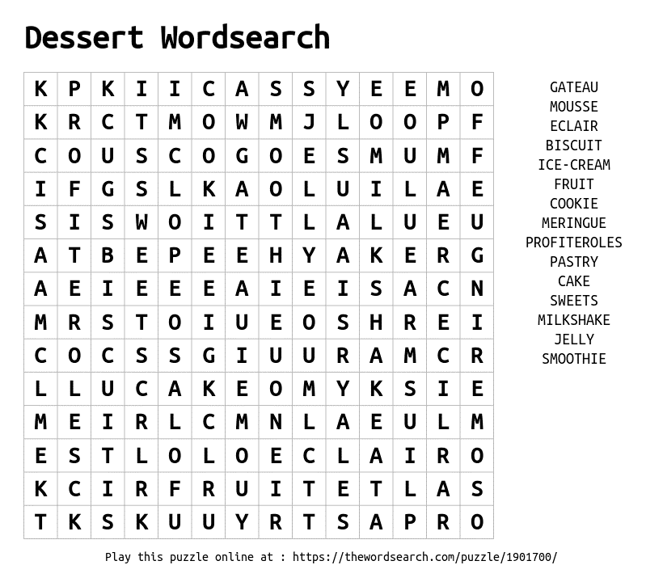

**Dessert Wordsearch**

GATEAU  
MOUSSE  
ECLAIR  
BISCUIT  
COOKIE

MILKSHAKE  
ICE-CREAM  
MERINGUE  
PROFITEROLES  
SMOOTHIE

CAKE  
SWEETS  
FRUIT  
JELLY  
PASTRY

My husband purchased a world map and then gave me a dart and said, “Throw this and wherever it lands—that’s where I’m taking you when this pandemic ends.” Turns out, we’re spending two weeks behind the fridge.

I never thought the comment “I wouldn’t touch them with a six-foot pole” would become a national policy, but here we are!

This morning I saw a neighbour talking to her cat. It was obvious she thought her cat understood her. I came into my house, told my dog – we laughed a lot.

Nothing like relaxing on the couch after a long day of being tense on the couch.

What’s the best way to avoid touching your face?   
**A glass of wine in each hand!**

**If coronavirus isn’t about beer, how come I keep seeing cases of it?**

If I keep stress-eating at this level, the buttons on my shirt will start socially distancing from each other!

Why did the chicken cross the road?   
Because the chicken behind it didn’t know how to socially distance properly!

So many coronavirus jokes out there, it’s a pundemic!

**Trees Wordsearch**

Warm Homes

**Leicestershire County Council has partnered with E.ON and Age UK to launch the Leicestershire Warm Homes Fund.**

If you don’t have gas central heating, the fund may be able to fully fund installation for you! If you’re not connected to gas, they can help you with that too.

Even if you already have gas central heating, the scheme can help with the following:

* Additional improvements such as having cavity wall and loft insulation fitted.
* A check to see if you’re entitled to benefits such as the £140 Warm Home discount on energy bills.
* Advice on finding a better energy tariff
* Priority support in case of a power cut

You are eligible for support if you receive the guarantee element of Pension Credit, Attendance Allowance, Disability Living Allowance or a number of other benefits.

Alternatively, support may be available if your annual household income is below £21,780.

For more information or for help applying, call **First Contact Plus on 0116 305 4286.**

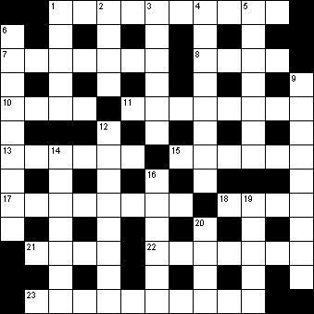

RUBBER  
PINE  
OAK  
MAPLE  
CONIFER  
SYCAMORE

BIRCH  
MAGNOLIA  
WILLOW  
BANYAN  
APPLE  
CHESTNUT  
LAUREL

BEECH  
PALM  
CEDAR  
LARCH  
WALNUT  
FIR  
ELM

**ADVERTISEMENT**

DOWN:  
1 Imitate (5)

2 Sodium chloride (4)

3 Come to the destination (6)

4 Postponement (8)

5 Soon (7)

6 Morning meal (9)

9 Judicial penalties (9)

12 Tyrannical (8)

14 Capital of Kenya (7)

16 Jail (6)

19 Trainee officer (5)

20 Female horse (4)

ACROSS:

1 Badly dealt with (10)

7 Countryside walker (7)

8 Liberated (4)

10 Curved structure (4)

11 All people (8)

13 Fought with swords (6)

15 Material for violin strings (6)

17 Indoor footwear (8)

18 Scrutinise (4)

21 Fortified wine (4)

22 Bind tight with clothes (7)  
23 Unhappy (10)

**Crossword**

ANSWERS ON THE BACK PAGE

**Exercises**

It’s important that we get some exercise every day to maintain our strength and mobility. This is especially vital when lockdown means we aren’t able to get out as often as we would like. Here’s some simple exercises from the NHS website that can be done at home, no fancy equipment needed!

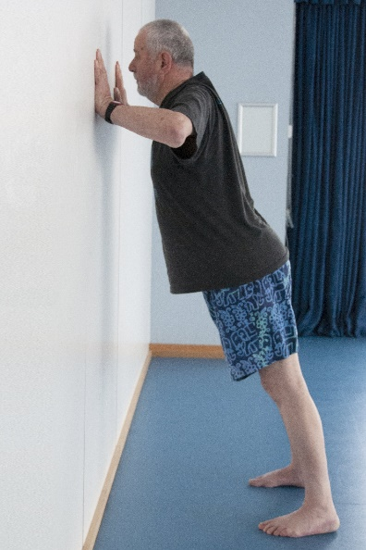

Wall Press-Up

A. Stand at arm's length from the wall. Place your hands flat against the wall at chest level, with your fingers pointing upwards.

B. With your back straight, slowly bend your arms, keeping your elbows by your side. Aim to close the gap between you and the wall as much as you can.

C. Slowly return to the start.

Attempt 3 sets of 5 to 10 repetitions.

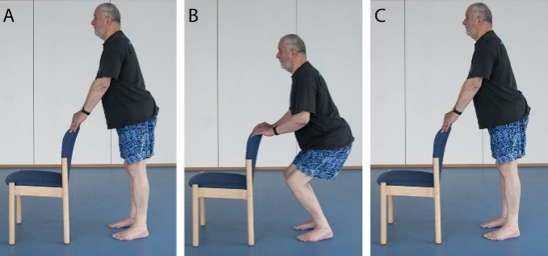

Mini-Squats – Repeat 5 times

A. Rest your hands on the back of the chair for stability and stand with your feet hip-width apart.

B. Slowly bend your knees as far as is comfortable, keeping them facing forwards. Aim to get them over your big toe. Keep your back straight at all times.

C. Gently come up to standing, squeezing (clenching) your buttocks as you do so.

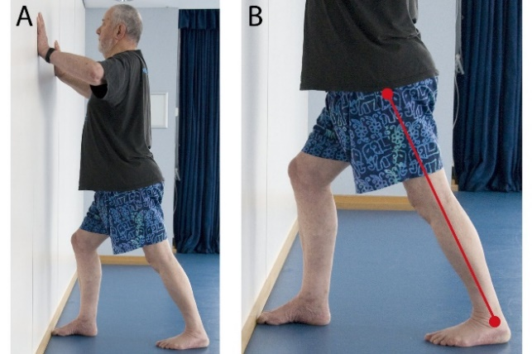

Calf Stretches – Repeat 3 times

A. Place your hands against a wall for stability. Bend the right leg and step the left leg back at least a foot's distance, keeping it straight. Both feet should be flat on the floor.

B. The left calf muscle is stretched by keeping the left leg as straight as possible and the left heel on the floor.

C. Repeat with the opposite leg.

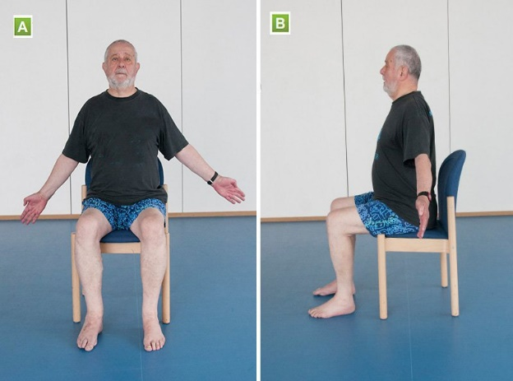

Chest Stretches – Repeat 5 times

A. Sit upright and away from the back of the chair. Pull your shoulders back and down. Extend your arms out to the side.

B. Gently push your chest forward seconds and up until you feel a stretch across your chest.

Hold for 5 to 10 seconds.

Heel-to-toe Walk

A. Standing upright, place your right heel on the floor directly in front of your left toe.

B. Then do the same with your left heel. Make sure you keep looking forward at all times. If necessary, put your fingers against a wall for stability.

Try to perform at least 5 steps. As you progress, move away from the wall.

<https://www.nhs.uk/live-well/exercise/> for more exercises!

Neck Stretch – Repeat 3 times

A. Sitting upright, look straight ahead and hold your left shoulder down with your right hand.

B. Slowly tilt your head to the right while holding your shoulder down.

C. Repeat on the opposite side.

Hip Stretches

A. Sit upright and do not lean on the back of the chair. Hold on to the sides of the chair.

B. Lift your left leg with your knee bent as far as is comfortable. Place your foot down with control.

C. Repeat with the opposite leg.

Calf Raises – Repeat 5 times

A. Rest your hands on the back of a chair for stability.

B. Lift both heels the floor as far as is comfortable. The movement should be slow and controlled.

Upper Body Twist – Repeat 5 times

A. Sit upright with your feet flat on the floor, cross your arms and reach for your shoulders.

B. Without moving your hips, turn your upper body to the left as far as is comfortable. Hold for 5 seconds.

C. Repeat on the right side.

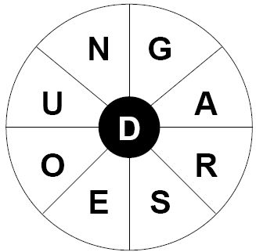

**Word Wheel**

**Sports Quiz**

Make as many words as you can using the letters in the wheel!

If you want to make it harder, all the words have to contain the central letter ‘D’.

Can you find the nine letter word?

1) Who was the top try scorer at the 2019 Rugby World Cup?  
a. Kotaro Matsushima b. Kenki Fukuoka c. Josh Adams d. Cheslin Kolbe

2) Only two women won more than two tennis majors during the 2010s: Serena Williams and…?  
a. Angelique Kerber b. Victoria Azarenka c. Maria Sharapova d. Kim Clijsters

3) What does the colour black represent in the Olympic rings?  
a. War b. Ancient History c. Africa d. Willpower

4) Who was the first European to win five points in a Ryder Cup match?  
a. Tommy Fleetwood b. Sergio Garcia c. Francesco Molinari d. Rory McIlroy

5) Which British boxer is the current WBC heavyweight champion?  
a. Anthony Joshua b. Dillian Whyte c. Daniel Dubois d. Tyson Fury

6) Who has won the most World Athletics Championship medals in history?  
a. Shelly-Ann Fraser-Pryce b. Usain Bolt c. Carl Lewis d. Allyson Felix

7) Which para athlete competes in cycling and athletics?  
a. Kadeena Cox b. Stef Reid c. Emma Wiggs d. Dame Sarah Storey

8) The Los Angeles Lakers and New York Knicks play which sport?  
a. Baseball b. American Football c. Basketball d. Ice Hockey

9) Which country won the first ever Women’s Rugby World Cup in 1991?  
a. Fiji b. United States c. Germany d. Canada

10) Which US state holds golf’s Masters tournament?  
a. Florida b. Alabama c. North Carolina d. Georgia

**Word Scramble**

Unscramble the words to find some everyday household objects!

1. ELOPETHEN
2. PCRETA
3. INOVELSITE
4. AVOWCRIME
5. BIDNUTS

6. ERVOHO  
7. OFSLOTTOO  
8. LOOOXTB  
9. CASTURN  
10. BAPDUROC

11. AMPLEENTICE  
12. ETKELT  
13. ORRRIM  
14. ALTOBLETCH  
15. ACESPUNA

**Definitions**

a. a dance b. a lizard c. a straw hat

a. worldly b. offal c. fertiliser

a. a tingle b. to stich c. a tabby cat

a. a twisted neck b. a Spanish pastry c. a spiral staircase

a. a cooking spice b. almost a villain c. a town

**Logic Puzzle**

What are the correct definitions of these unusual words?

1. CUECA

2. MUNDUNGUS

3. DINDLE

4. TORTICOLLIS

5. DEMIVILL

A farmer wants to cross a river and take with him a wolf, a goat and a cabbage. He has a boat, but it can only fit himself plus either the wolf, the goat or the cabbage. If the wolf and the goat are alone on one shore, the wolf will eat the goat. If the goat and the cabbage are alone on the shore, the goat will eat the cabbage. How can the farmer bring the wolf, the goat and the cabbage across the river without anything being eaten?

ANSWERS ON THE BACK PAGE

Find the missing word that links these pairs of words to make two recognizable words/phrases!   
Eg. If the question is Wedding ______ Stand, the missing word is Cake.

**Link Words**

**Sudoku**

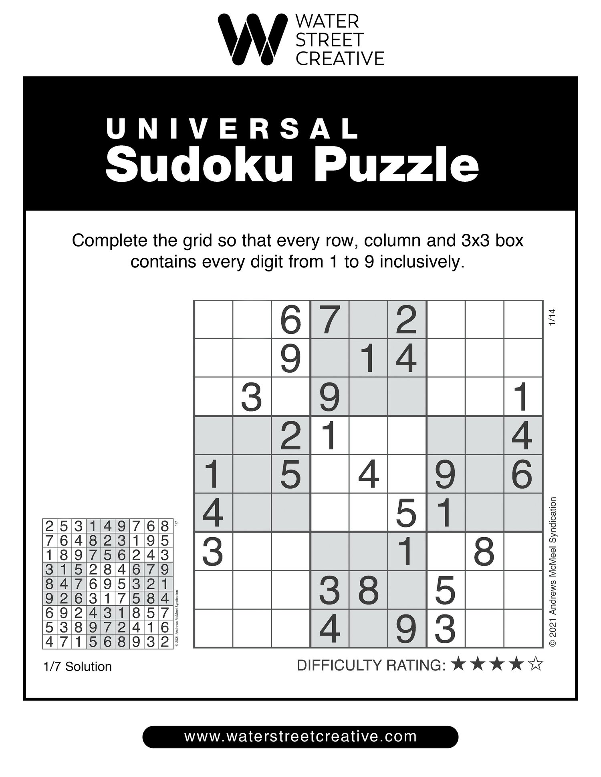

_______________________________________________________________________________________________________________________________________

_______________

Gown

Box

Cleaner

Stick

China

Jar

Aid

Cloth

Bin

Paper

1. Tennis
2. Chain
3. Wind
4. Cricket
5. Funny
6. Looking
7. Rubber
8. Times
9. Cat
10. Horse

1) What is the home of a rabbit called?

2) Gelbvieh, Corriente and Dexter are all breeds of which animal?

3) What is the more common name of the Aurora Borealis?

4) Which three coniferous trees are native to Britain?

5) From which tree is cork obtained?

6) What kind of creature is a sand mason?

7) What is the largest native British bird?

8) What is the tallest living animal?

9) What two species of animal always give birth to twins?

**Nature Quiz**

**RIDDLE**

A cowboy rides into town on Friday. He stays three days, then rides out of town on Friday. How?

Fill in the grid so that each row, column and square contains the numbers 1-9. Each number can only appear once in each row, column and square.

The answer in on the back page! This puzzle is harder than average so if you get stuck, try filling in one of the squares with all the numbers from the answer and trying again!